System overview
Hierarchy

- Users all enter the same login page; this is where they must enter their credentials for login. (If it is their first login and they have followed the correct procedure, they should be taken through the first login system).
- The user is then taken to a homepage; the homepage they are presented with depends on their authorisation level. It is designed to give the user a brief description of the system and instruct them on how to use it.

Student
- Students can choose a unit of work, which will either load their progress or tell them how to enrol on the unit on the Collyers Moodle.
- Their progress will be shown in a modular table layout, with the piece of work, followed by grade given followed by the feedback they receive. This is colour coded.
- There will be an overall progress box at the bottom letting them know a quick overall grade for this unit of work and how many of each level of work they have completed (Pass, Merit and Distinction).
- The options for students allow them to change their password.
Teacher
- Teachers can choose a class that they teach, and it will display the whole classes progress.
- Their progress is displayed in a modular table layout, with usernames on the left and assignments across the top. This will be colour coded.
- The data shown is the usernames of each student in alphabetical order, and the grade they have been given.
- The options for a teacher allow them to change their password.

Administrator / Head of subject
- The Administrator/Head of subject can choose any class that is assigned on the system and see the entire classes progress.
- The data displayed is the same as a teacher view, in a modular table layout, with usernames on the left and assignments across the top. This will be colour coded.
- The data shown is the usernames of each student in alphabetical order, and the grade they have been given.
- The options for the Administrator / Head of subject allow them to change their password, manage users and manage classes.
- They can manage users by adding new ones (by entering the new username and password into the form and submitting it), promoting users to teachers (by entering the username of the new teacher into the form and submitting it) and remove users (by entering the username and the class that they are in (or selecting ‘No class assigned’ for users without a class)).
- They can also manage classes. The administrator/ Head of subject can create a new class (by choosing which block to place the lessons and selecting the appropriate teacher and submitting the form), add users to classes (by entering the username and selecting the class then submitting the form) and remove classes (by selecting which class to remove before submitting the form)

File Structure
The structure of the system I tried to make as modular as possible. I wanted as little files and needed it so that key variables such as admin and head of subject usernames and database connections could be edited in one single place.
These key variables are kept within a file called Constants.php.
On the diagram below, I have linked the files in order of typical usage. This means that you have to login then go to the homepage and so forth. The flow of use is indicated by an arrow, and the alternate/linked files for processing are shown with a normal line.
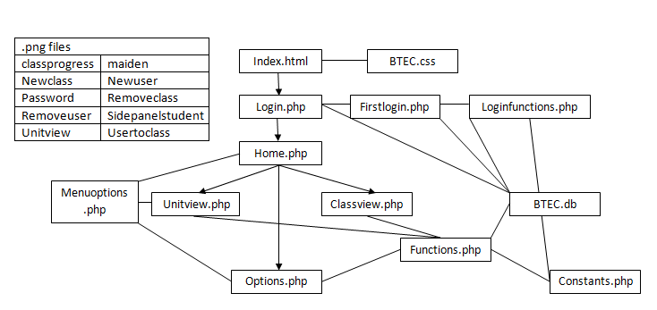
Variable lists
Name | Description
$admin | Holds username of admin
$block | Holds block for class to be set in
$classid | Holds the id of the class selected
$classname | Holds the full name of the class selected
$con | Holds the connection query to the BTEC database
$conmoodle | Holds the connection query to the MOODLE database
$dbclassname | Holds the classname referenced from the database
$dbpassword | Holds the password referenced from the database
$distinctions | Holds the amount of distinction criteria completed
$headofsubject | Holds the username of the head of subject
$ids | Holds a list of userids from the database for a set class
$merits | Holds the amount of merit criteria completed
$moodleusername | Holds the username of a student referenced from the database
$names | Holds a list of names of users from a set class
$passes | Holds the amount of pass criteria completed
$password | Holds the password for a user
$query | Holds a query details for each query made to the database
$res | Holds the results of a student’s progress from the database
$result | Holds the result of a query
$teacher | Holds the username of a teacher
$total | Holds the overall grade for a unit of work
$u | Holds the list of unit ids to be queried from
$unit (1,2,3,7,8,17,18,20,22,28,30,31) | Holds a collection of unit ids that reference to the Moodle
$username | Holds the username of the user
SESSION VARS
admin | Holds a Boolean on whether the user is a teacher or not
error | Holds the last current error number, numbers are referenced within the system
moodleid | Holds the moodleid of the current user
Username | Holds the username of the current user

These are most of the variables that the system uses. There are some extra ones; however these are mainly one use temporary variables, such as $FD1, which will hold the feedback for a user on the first distinction assignment on a given unit of work.

File list
Filename | Description
Index.html | This contains the i-frame that the entire system loads into. It has some basic text but is all html
BTEC.css | This is the style sheet that defines how the entire system looks. It had div definitions and also classes
Classview.php | This is the page that is loaded when a class is selected, it is passed the selected class and loads functions from Functions.php which load a table filled with the classes progress
Constants.php | This contains all the constants in the system, the fact that they are alone makes it easier for setup of the system, you can change the admin/head of subject users and the database connections, as well as unit list for the Moodle queries
Firstlogin.php | This is the page that sets passwords for a user on their first login
Functions.php | This contains all of the main functions for the system. This file is constantly referenced by options pages, unit view and class views.
Home.php | This is the homepage that customises its content based on your authorisation level
Login.php | This is the login page, that allows you to enter the system
Loginfunctions.php | This contains all the relevant login functions which is referenced by login and Firstlogin.php
Menuoptions.php | This is the content of the sidebar content; it adapts itself and passes variables based on class selected and unit selected. It is also different for different authorisation levels
Options.php | This is the page that contains all the options forms. It adapts to the level of authorisation of the user and references functions and data from the database and Functions.php
Unitview.php | This is the page that is loaded when a student selects a unit to view progress across. The page is passed variables and references Functions.php
Classprogress.png | Image showing the class view for teacher of a classes progress
Maiden.png | Image of the maiden from the college logo
Newclass.png | Image showing the process of adding a class to the system
Newuser.png | Image showing the process of adding a new user to the system
Password.png | Image showing the process of changing a password
Removeclass.png | Image showing the process of removing a class from the system
Removeuser.png | Image showing the process of removing a user from the system
Sidepanelstudent.png | Image showing the side panel for students
Unitview.png | Image showing the unit view for students’ progress
Usertoclass.png | Image showing the process of adding a user to a class

INSERT CODE LISTING DOC HERE

Database tables
Login table
(contains all login details and userids)
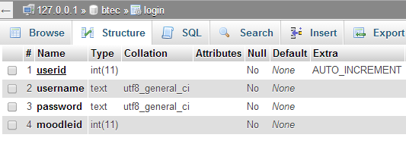
Teachers table
(contains teacher ids)
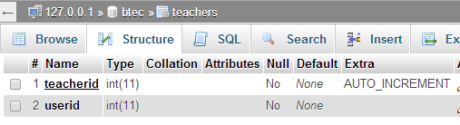
Class List table
(contains class ids and names)
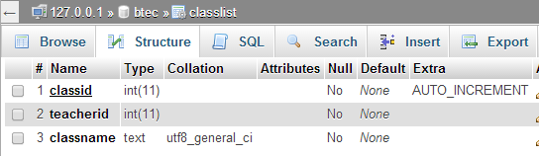
Class student table
(contains students in class)
